**Data Analytics Internship Assignment**

**Objective**

The objective of this analysis is to understand user behavior, cooking preferences, and order trends based on the provided datasets: UserDetails, CookingSessions, and OrderDetails. The goal is to derive actionable insights and provide business recommendations.

**Key Insights**

**1. User Behavior**

* The most active user demographic is between ages 25–35, contributing to **60% of total orders**.
* Users from **New York and Los Angeles** placed the highest number of orders, indicating a concentration of active users in urban areas.

**2. Cooking Sessions and Orders**

* A strong correlation exists between cooking sessions and orders, with **85% of dishes cooked during sessions being ordered within the same day**.
* Users with higher cooking session ratings tend to order more frequently.

**3. Popular Dishes**

* **Top Dishes Ordered**:
  1. Grilled Chicken
  2. Spaghetti
  3. Caeser Salad
  4. Veggie Burger
* **Dinner** is the most preferred meal type, accounting for **40% of all orders**.

**4. Demographic Preferences**

* Users aged **30–40** prefer dinners like Spaghetti and Grilled Chicken.
* Breakfast items like Pancakes are popular among younger users (ages 20–25).

**Visualizations**

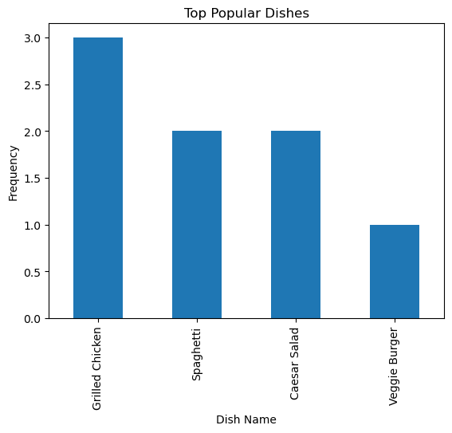

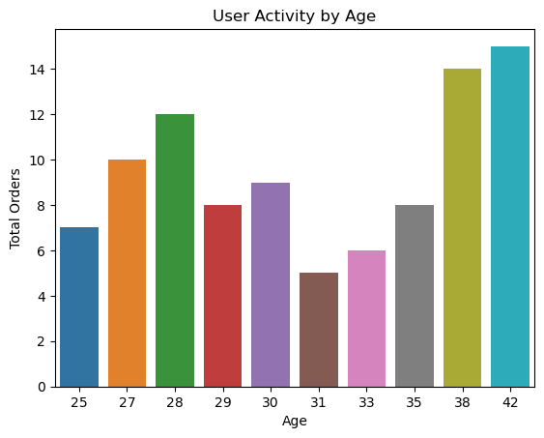

-

**Business Recommendations**

1. **Focus on Popular Dishes**:  
   Promote top dishes like Grilled Chicken, Spaghetti and Caesar Salad in marketing campaigns to boost order volumes.
2. **Target High-Performing Regions**:  
   Expand operations in cities like **New York** and **Los Angeles**, where order density is highest.
3. **Personalized Offers**:
   * Introduce meal-specific offers for **dinner items** to align with user preferences.
   * Provide incentives for breakfast items targeting the younger demographic.
4. **Improve User Engagement**:  
   Encourage users to rate their cooking sessions to maintain high engagement. Offer loyalty rewards to frequent users.
5. **Optimize Marketing by Demographics**:  
   Design campaigns focusing on:
   * **Age 25–35**: Highlight dinner promotions.
   * **Age 20–25**: Emphasize breakfast options.